**Chapter 7**

# Real-World Data

So far, we've been working purely in the abstract. It's time to take a look at some real data, and see if we can make any observations about it.

## Some Real World Data 7.1

Modern pirates plunder software, not silver. We have a file with the software piracy rate, sorted by country. Here's a sample of its format:

Country,Piracy

Australia,23

Bangladesh,90

Brunei,67

China,77

...

We'll load that into the piracy data frame for you:

> piracy <- read.csv("piracy.csv")

We also have another file with GDP per capita for each country (wealth produced, divided by population):

Rank Country GDP

1 Liechtenstein 141100

2 Qatar 104300

3 Luxembourg 81100

4 Bermuda 69900

...

That will go into the gdp frame:

> gdp <- read.table("gdp.txt", sep=" ", header=TRUE)

We'll merge the frames on the country names:

> countries <- merge(x = gdp, y = piracy)

Let's do a plot of GDP versus piracy. Call the plot function, using the "GDP" column of countries for the horizontal axis, and the "Piracy" column for the vertical axis:

> plot(countries$GDP, countries$Piracy)

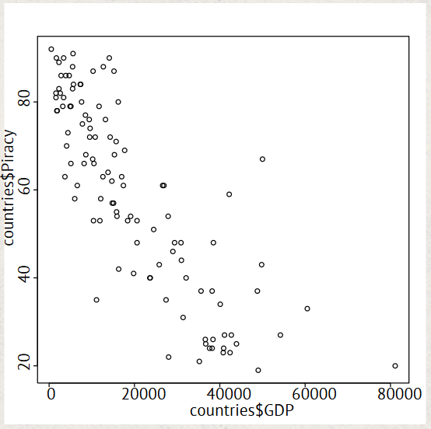

• It looks like there's a negative correlation between wealth and piracy - generally, the higher a nation's GDP, the lower the percentage of software installed that's pirated. But do we have enough data to support this connection? Is there really a connection at all?

R can test for correlation between two vectors with the cor.test function. Try calling it on the GDP and Piracy columns of the countries data frame:

> cor.test(countries$GDP, countries$Piracy)

Pearson's product-moment correlation

data: countries$GDP and countries$Piracy

t = -14.8371, df = 107, p-value < 2.2e-16

alternative hypothesis: true correlation is not equal to 0

95 percent confidence interval:

-0.8736179 -0.7475690

sample estimates:

cor

-0.8203183

The key result we're interested in is the "p-value". Conventionally, any correlation with a p-value less than 0.05 is considered statistically significant, and this sample data's p-value is definitely below that threshold. In other words, yes, these data do show a statistically significant negative correlation between GDP and software piracy.

• We have more countries represented in our GDP data than we do our piracy rate data. If we know a country's GDP, can we use that to estimate its piracy rate?

We can, if we calculate the linear model that best represents all our data points (with a certain degree of error). The lm function takes a *model formula*, which is represented by a *response variable* (piracy rate), a tilde character (~), and a *predictor variable* (GDP). (Note that the response variable comes *first*.)

Try calculating the linear model for piracy rate by GDP, and assign it to the line variable:

> line <- lm(countries$Piracy ~ countries$GDP)

• You can draw the line on the plot by passing it to the abline function. Try it now:

> abline(line)

Now, if we know a country's GDP, we should be able to make a reasonable prediction of how common piracy is there!

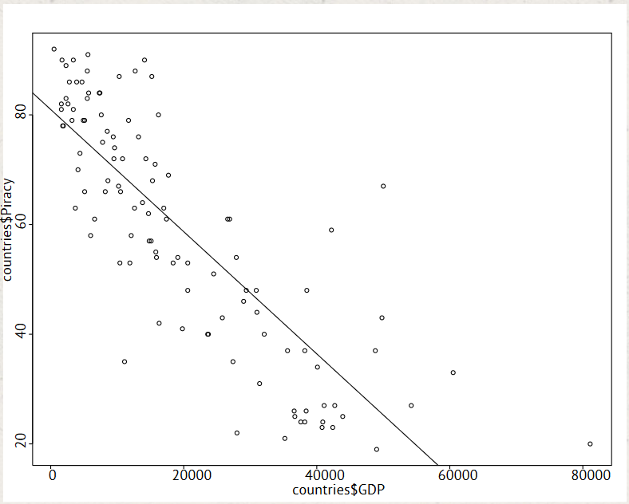

## • ggplot2 7.2

The functionality we've shown you so far is all included with R by default. (And it's pretty powerful, isn't it?) But in case the default installation doesn't include that function you need, there are still more libraries available on the servers of the Comprehensive R Archive Network, or CRAN. They can add anything from new statistical functions to better graphics capabilities. Better yet, installing any of them is just a command away.

Let's install the popular ggplot2 graphics package. Call the install.packages function with the package name in a string:

> install.packages("ggplot2")

• You can get help for a package by calling the help function and passing the package name in the package argument. Try displaying help for the "ggplot2" package:

> help(package = "ggplot2")

Information on package 'ggplot2'

Description:

Package: ggplot2

Type: Package

Title: An implementation of the Grammar of Graphics

Version: 0.9.1

...

• Here's a quick demo of the power you've just added to R. To use it, let's revisit some data from a previous chapter.

> weights <- c(300, 200, 100, 250, 150)

> prices <- c(9000, 5000, 12000, 7500, 18000)

> chests <- c('gold', 'silver', 'gems', 'gold', 'gems')

> types <- factor(chests)

The qplot function is a commonly-used part of ggplot2. We'll pass the weights and values of our cargo to it, using the chest types vector for the color argument:

> qplot(weights, prices, color = types)

Not bad! An attractive grid background and colorful legend, without any of the configuration hassle from before!

ggplot2 is just the first of many powerful packages awaiting discovery on CRAN. And of course, there's much, much more functionality in the standard R libraries. This course has only scratched the surface!

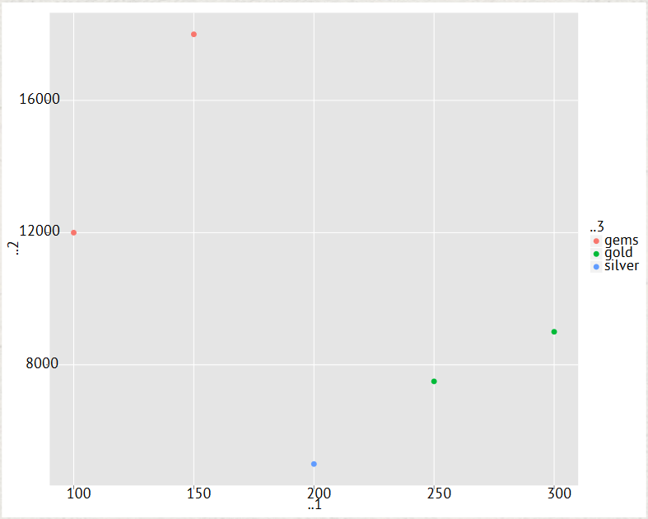

## Chapter 7 Completed

Captain's Log: The end of chapter 7. Supplies are running low. Luckily, we've spotted another badge!

We've covered how to take some real-world data sets, and test whether they're correlated with 'cor.test'. Then we learned how to show that correlation on plots, with a linear model.